Nuclear radiation detector

Pic 1

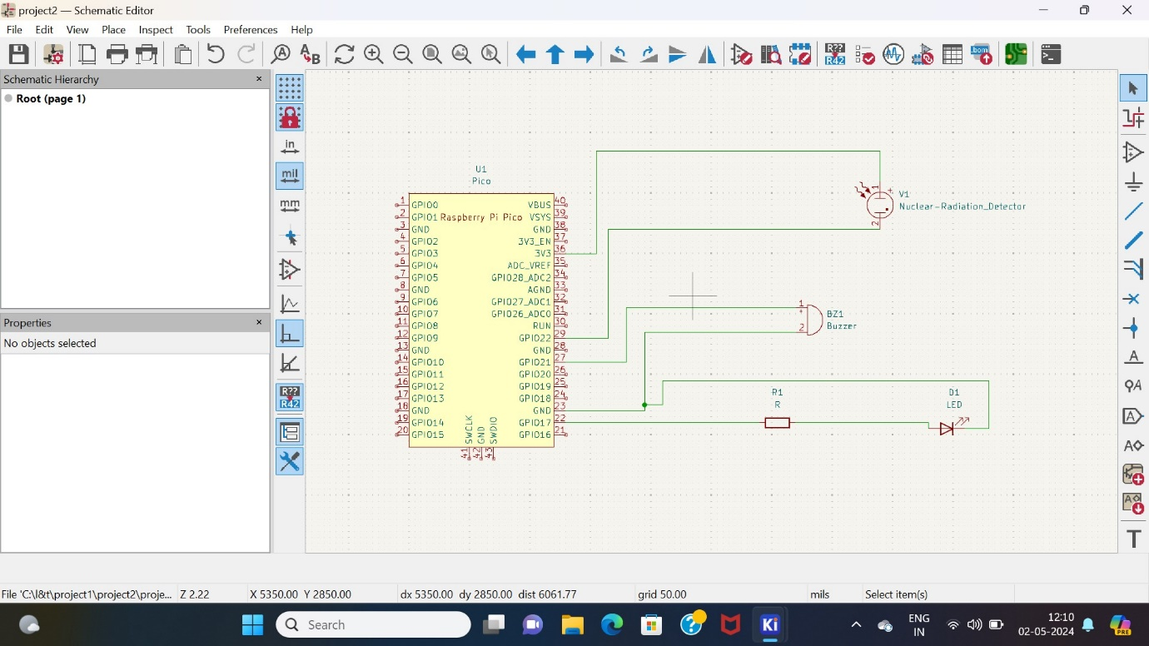

Pic 2

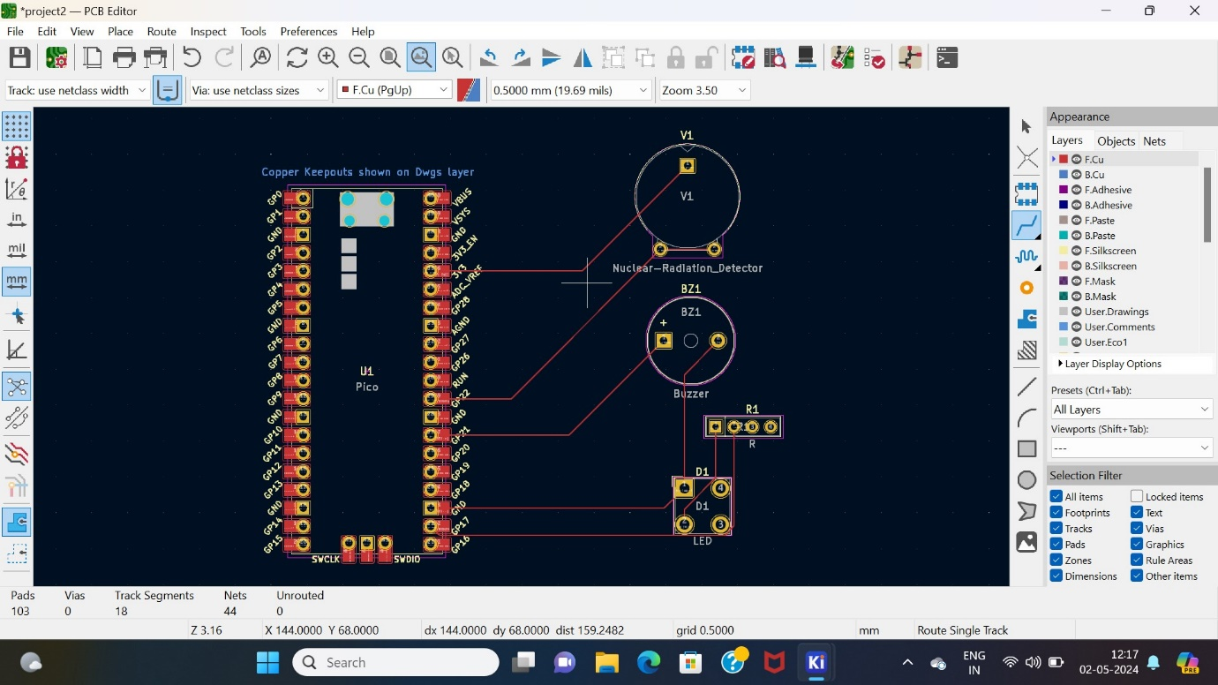

Pic 3

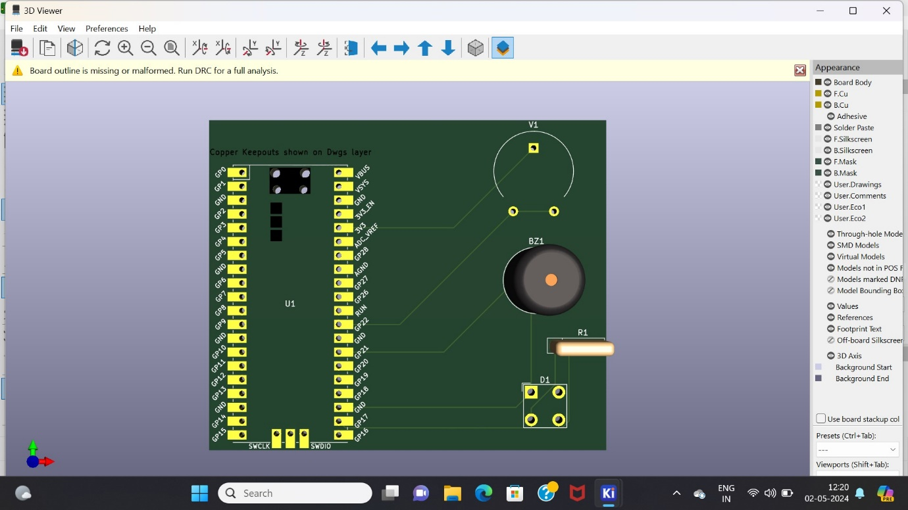

21781A04D2

21781A04D3

21781A04C6

21781A04E2

21781A04E7